Template – Proof of High School or GED Completion Form
The template named “Template – Proof of High School Graduation” is applicable to Anthology Student.

Purpose and Outcome
This template provides a form sequence and supporting workflow for a proof of high school or GED completion form to be submitted by a student. The sequence requires the following:
- A Student record must exist in the Anthology Student database.
- The student must have a Portal login to log into this authenticated sequence.
Upon completion of the sequence:
- The file submitted in the form sequence is saved to the student’s Documents Center in Anthology Student.
- The status of the uploaded document is set to “On File” with a “Received Date” indicating the day when the upload occurred.

Prerequisites
The template was built in Forms Builder using the applications listed below. The template is forward compatible with later versions of the listed applications.
Application | Compatibility Version
Forms Builder Designer and Renderer | Compatibility Matrix
Web Client for Anthology Student
Workflow Composer
Packages installed from Package Manager in Workflow Composer | Activities and Contracts (V2)  Contracts (V1)  Forms Builder Contracts  Note: Ensure that the Forms Builder Contracts package used in Workflow Composer is aligned with the version used in the Forms Builder. Additionally, confirm that both Activities and Contracts (V1) and Activities and Contracts (V2) packages in Workflow Composer match the versions used in the Student Web Client to avoid compatibility issues.  It depends on which product is being used, for example:  For CRM:  Activities And Contracts (CRM)  Forms Builder Contracts
Workflow Tracking Database | N/A
Staff STS | 3.3.x

Step 1: Download and Import the Template
- Download the template file (xml) to your environment (local drive or network location).
- Log into Forms Builder Designer.
- Click the Export/Import tile.
- Select the Import tab.
- Click Select exported file and navigate to the downloaded template file (xml).
- Click Import.
Note: Import may fail if same files name is already available in environment or overwrite option.
- Export/Import

The following forms will be imported:

WelcomeNew

Campus University - Proof of High School or GED Completion

Custom – Confirmation

Step 2: In Form Designer…
- From the Forms slide out, select the Campus University - Proof of High School or GED Completion form.
- Customize the form for your environment. Modify properties on current fields to make them required, etc., or add/remove fields on form.
Make sure you edit the text in the Labels and HTML controls as applicable for your institution.
- Fields and Components
- Save the form.
- Repeat steps 1-3 for the following forms:

Custom – Confirmation
- WelcomeNew

Step 3: In Sequence Designer…
- Select the Campus University - Proof of High School or GED Completion sequence.
The sequence contains the following forms in the following order:

WelcomeNew

Campus University - Proof of High School or GED Completion

Custom – Confirmation
The Custom – Confirmation form is selected as the End State Form for the sequence.
- Click Save As to create a copy of the sequence/workflow and customize the copy for your use. This way you can always refer to the original sequence/workflow you downloaded.
- Optional - Add a custom style (theme) associated with your campus.
- Themes
- Select your sequence in the Sequences pane.
- In the Properties Pane:
  - Ensure that the Authentication Product is Student.
- Select the End State Form named “Custom - Confirmation”.
- Save the sequence.
- Open the associated sequence workflow.
Depending on your environment, either click Open Workflow in Sequence Designer or launch a local installation of Workflow Composer.
- Open the Workflows for a Sequence

Step 4: In Workflow Composer…
- Double-click the Next transition from the first form/state named “Welcome/New” and locate the LookupReferenceItem activity.
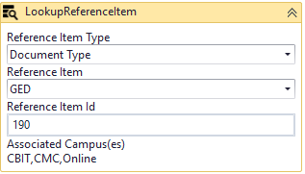
In the Reference Item List and Reference Item drop-down lists, select values that are appropriate for your environment.
- LookuoReferenceItem activity

- Double-click the Submit transition to the End state and locate the GetAttachments activity.
Check the ControlIdentifier in the Properties of the GetAttachments activity.
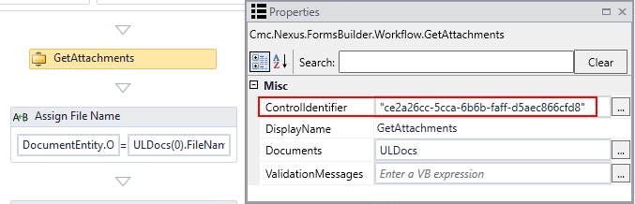
In Form Designer, confirm that the GetAttachments ControlIdentifier matches the Id of the File Upload control in the Campus University - Proof of High School or GED Completion form.
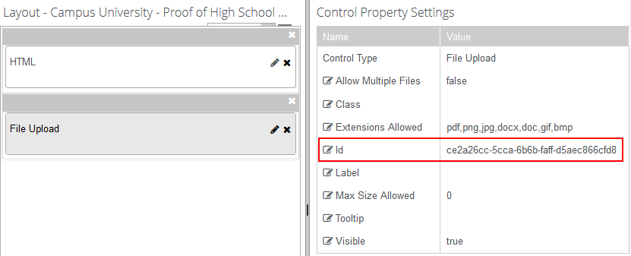
- In the Assign Status activity below the GetAttachments activity, check that the StatusId Value for “Received” status is appropriate for your Anthology Student database.
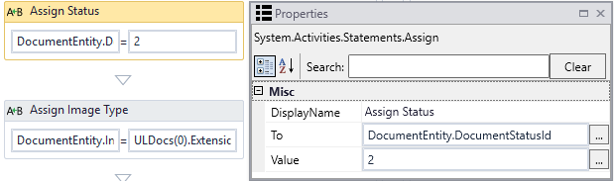:

Step 5: In Forms Renderer and Anthology Student…
Select your sequence and try it out!
- Sequence List
- Find your Campus University - Proof of High School or GED Completion sequence and copy the URL to the clipboard.
- Log in to Portal as a student and complete the form sequence.
- In Anthology Student,
  - Verify that the document submitted as proof of high school or GED completion was added to the student’s Document Center.
  - Verify that the document’s status in the Document Center is updated to “On File” with a “Received Date” of today.

Step 6: Lastly…
Once your updated sequence has been tested successfully, it is recommended that you disable the workflow for the original Template version.
- In Workflow Composer, in the Server section of the ribbon, click Open.
- Find the workflow named “Campus University - Proof of High School or GED Completion Sequence”.
- Clear the Enabled check box and click Save.

